Sharing the AMI image with another aws account

First we need to create an AMI of instance that we already created named as demo

Go to ec2 🡪 instances, then the below page will open

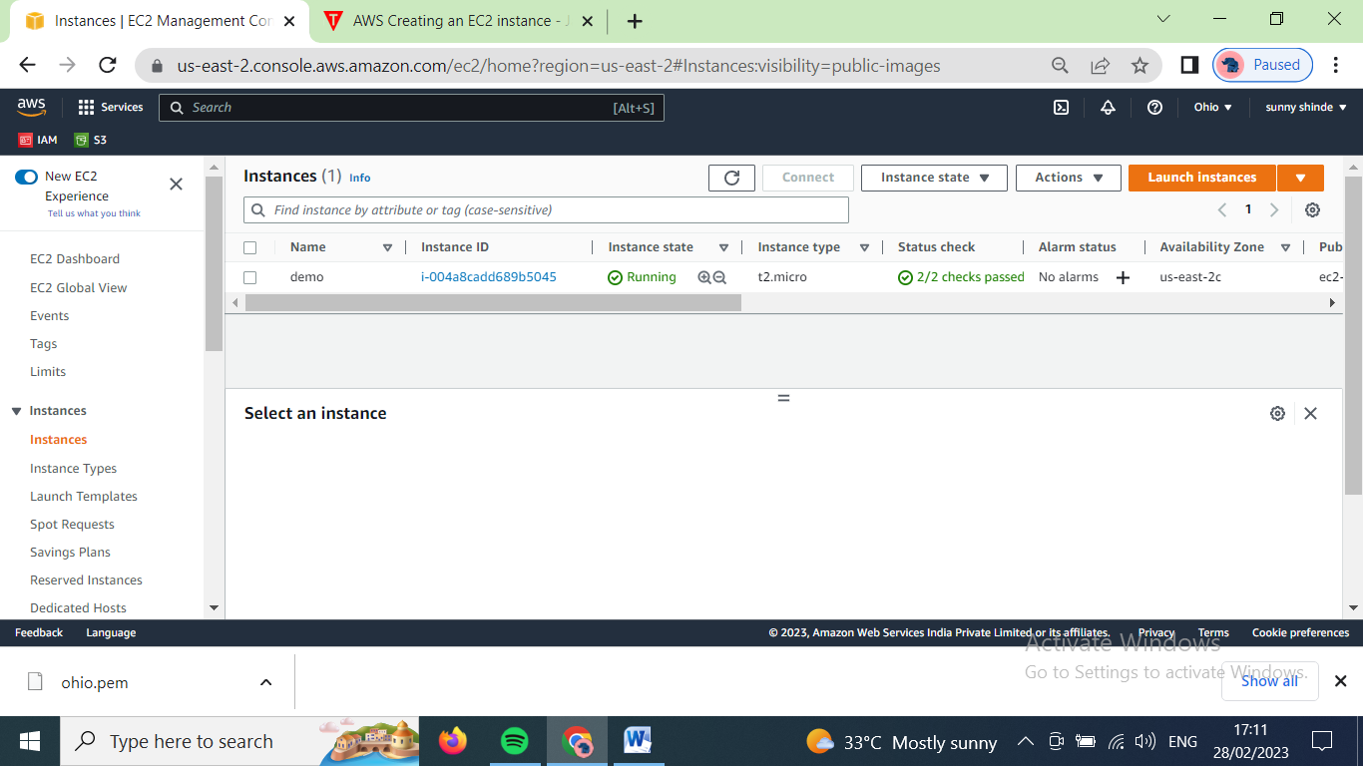

Select the demo instance and click on actions 🡪 image and templetes 🡪 create an image

Then the below page will open, where we add image name, description and tages.

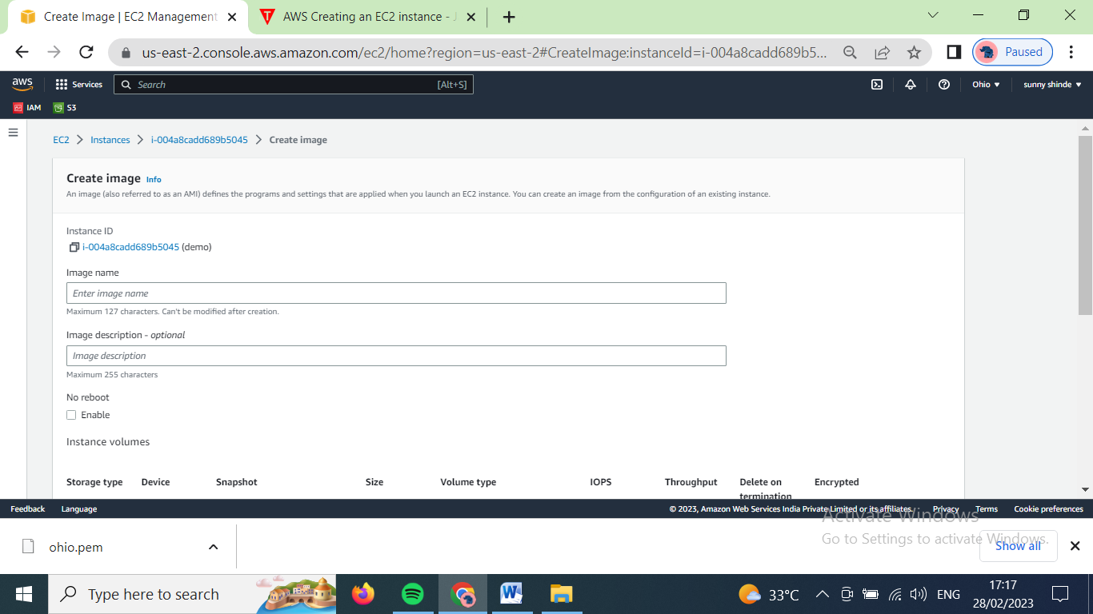

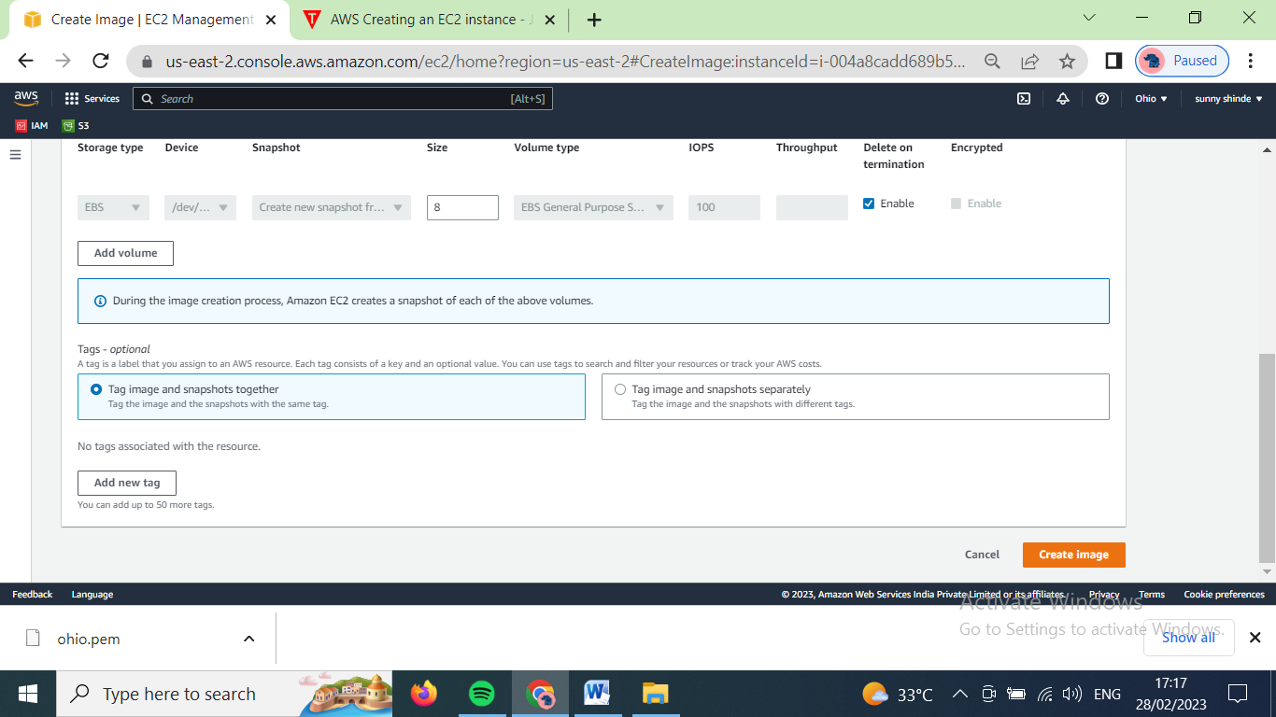

After filling the information click on create image

(we created AMI named demo3)

Then go to the navigation bar images 🡪 AMIs

Then below page will open

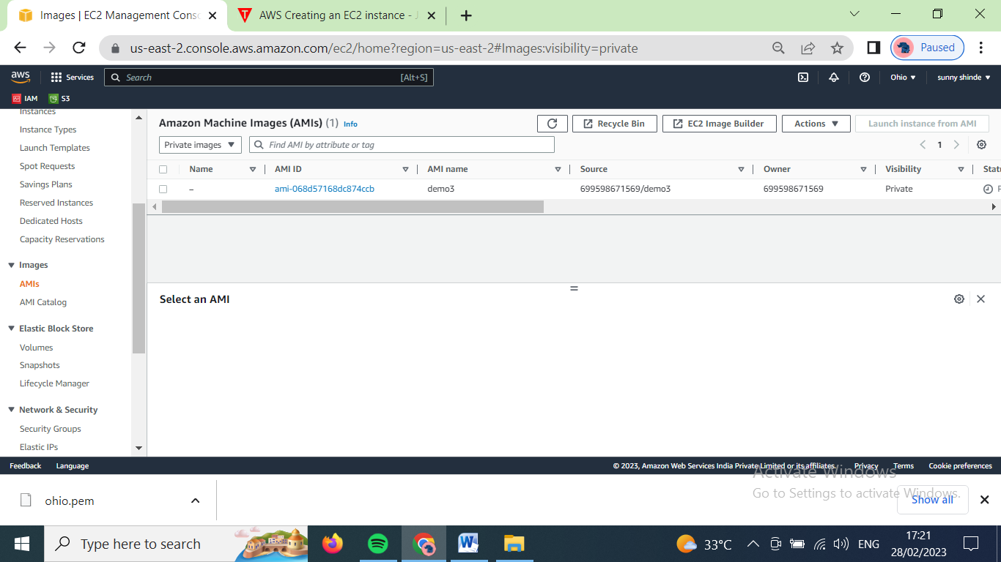

Now to share the AMI, select the image, click on actions 🡪 edit AMI permissions

The below page will open

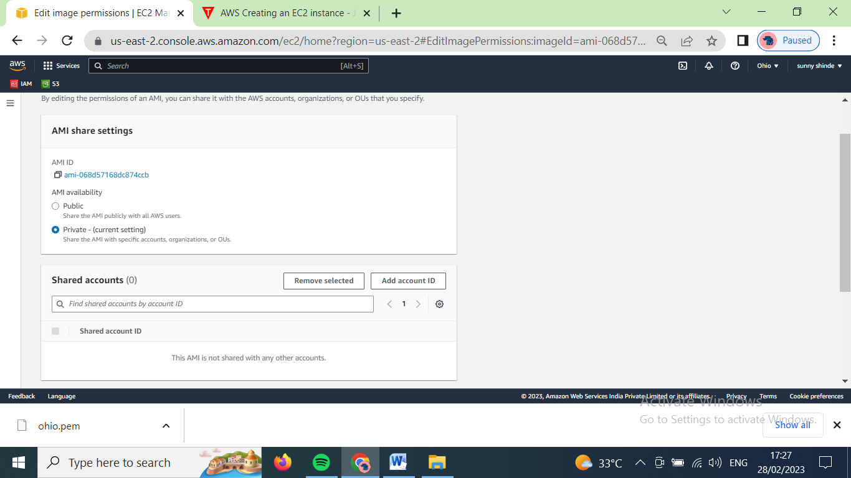

Click on add account id

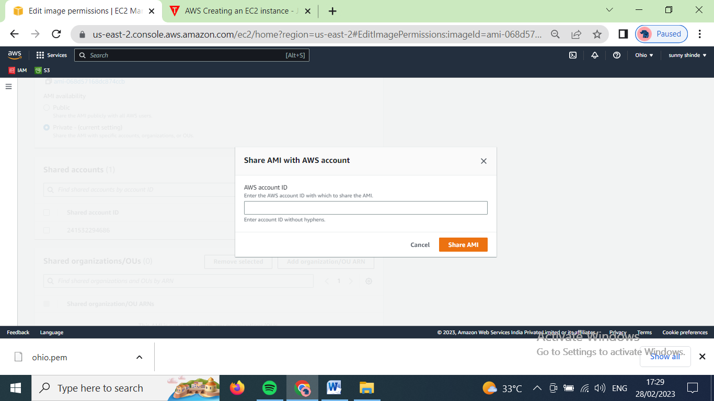

Click on share AMI, then click on save changes